**The Report of Urban Sound Classification Project**

Yang Seong Jin, Choi Ji Un, Choi Young Han, Chae Jee Seung, and Gwak Geunyoung

1Woosong University, Daejeon, Republic of Korea

**Abstract.** Our team's topic was to sort out the noise that might be in the city into sound files. The application of this topic will help artificial intelligence recognize the urban environment more clearly. When distinguishing, we used four main models. SVC, k-NN, Random Forest, and Naive-Bayes models. SVC draws a line to distinguish a class, so it draws a line that allows the class groups to pass as far in the middle as possible. k-NN is a classifier that classifies data into k centrioles. Random Forest is a classifier that averages out all the predictions made by several Decision Trees. Naive-Bayes is a probability classifier with the Bayes’ theorem applied. Our dataset was originally an audio file with 10 classes of 6GB, but after the feedback, we reduced it to 3 classes and reduced the number. In conclusion, the Random Forest model showed a higher performance relatively than other models in the environment we created.

# Introduction

First, I will introduce four models one by one from many papers. "A support vector machine (SVM) is a computer algorithm that learns by example to assign labels to objects.”(Noble, 2006) We will use Support Vector Classifier(SVC) which is using similar logic as SVM. "K-nearest-neighbor (kNN) classification is one of the most fundamental and simple classification methods and should be one of the first choices for a classification study when there is little or no prior knowledge about the distribution of the data."(Peterson, 2009) "The random forest algorithm, proposed by L. Breiman in 2001, has been extremely successful as a general-purpose classification and regression method."(Biau & Scornet, 2016) "The naive Bayes classifier greatly simplify learning by assuming that features are independent given class."(Rish, 2001) All four are useful models to use as Classifiers, and we picked them out because we thought they would fit our data well.

After the introduction, we will present Literature Review, Proposed Model, Experimental setup and result analysis, and Conclusion chapters in order.

# Literature Review

Feng Rong (2016) dealt with the topic that to distinguish sounds with machine learning models just similar as our project. But He only used the model SVM, where we wanted to try other models too and see the difference performance among different machine learning models.

# 3 Proposed Model

# Every model is used from scikit learn library and with default parameters if there is no comment.

1. SVM

sklearn.svm.SVC

Fig 1. Primal Problem-solving equation.

Fig 2. Dual Problem-solving equation.

Fig 3. Decision Function.

1. K-NN Grid Search Cross Validation

sklearn.neighbors.KNeighborsClassifier

sklearn.model_selection.GridSearchCV

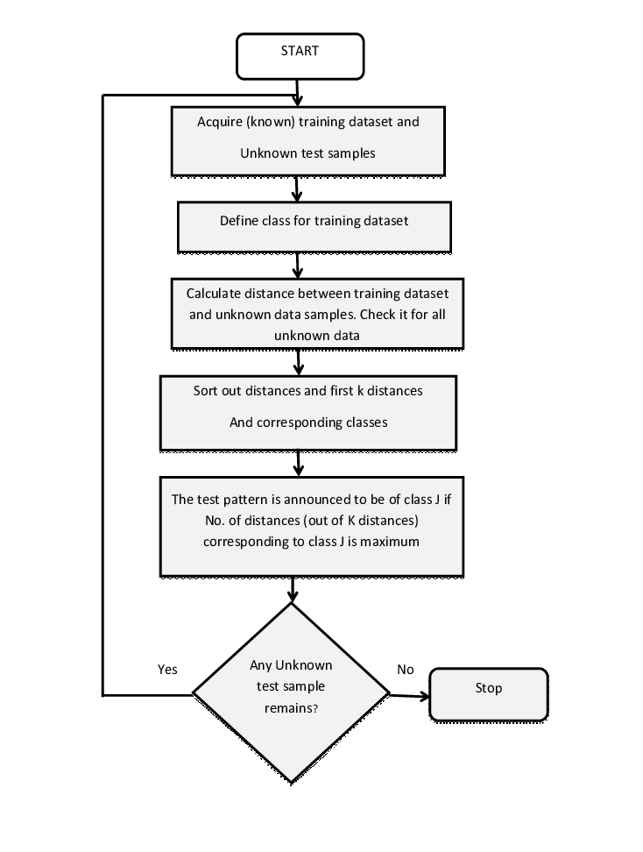

Fig 4. Block Diagram of k-NN

1. Random Forest

sklearn.ensemble.RandomForestClassifier

edited parameter: criterion = ‘entropy’

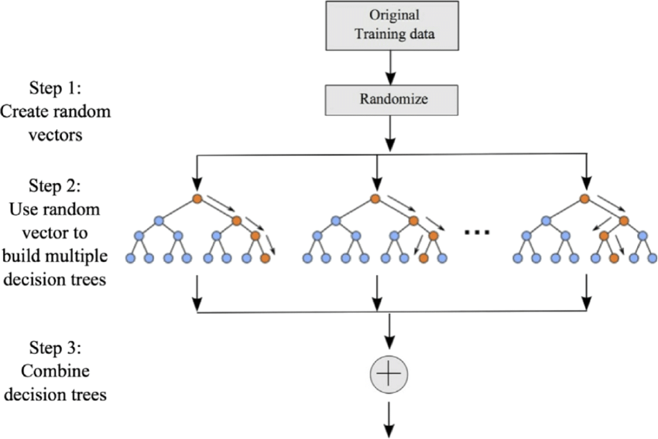

Fig 5. Block Diagram of Random Forest

1. Naïve Bayes

sklearn.naive_bayes.GaussianNB

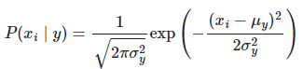

Fig 6. Naive Bayes' probability equation.

# 4 Experimental Setup and Result Analysis

The dataset we used is called UrbanSound8K, which was posted on the Kaggles. There are a total of ten classes of this data, and we have selected three classes: drilling, engine_idling, jackhammer, and reduced the number of data when reducing classes after the feedback. Thus, a total of 1,196 wav files, including 400 drilling, 398 engine_idling, and 398 jackhammer, have become our datasets. Performance metrics were used to analyze the results, and the results were analyzed with the accruacy values shown.

Fig 7. 4 models performance metrics

As you can see, the results of the Random Forest model were better than the others. However, the performance itself is not the desired result, as even Random Forest's accuracy is around 40%. After searching for bad result, we found out that the raw dataset itself was pre-sorted at 10fold, and there was also a warning not to mix it randomly. As a result, there is a serious flaw in accuracy. However, all models took the same input, at least confirming that the random forest model relatively performed well in given environment.

# 5 Conclusion

As a result, Random Forest produced relatively good results in the same given environment. However, the performance is in a critical condition, and to improve it, the data itself may need to be 10fold cross validation as it was designed, or we may need to find out more about the existence of a better model or create our own deep learning sequence.

# References

1. Biau, G., & Scornet, E. (2016). A random forest guided tour. Test, 25(2), 197-227.
2. Noble, W. S. (2006). What is a support vector machine?. Nature biotechnology, 24(12), 1565-1567.
3. Peterson, L. E. (2009). K-nearest neighbor. Scholarpedia, 4(2), 1883.
4. Rish, I. (2001, August). An empirical study of the naive Bayes classifier. In IJCAI 2001 workshop on empirical methods in artificial intelligence (Vol. 3, No. 22, pp. 41-46).
5. Rong, F. (2016, December). Audio classification method based on machine learning. In 2016 International conference on intelligent transportation, big data & smart city (ICITBS) (pp. 81-84). IEEE.